

**CSE2007 : Database Management Systems**

**Name :** Gudi Varaprasad

**Reg. No. :** 19BCE7048

School of Computer Science and Engineering

**Lab Slot :** L45 + L46

**Date :** 18 – 02 – 2021

**Submitted to :** Ms. Dhanavanthini madam

**Lab Cycle-I (SQL)**

(up to 10 questions)

**Creation of General Hardware Database (GHD), Insertion of data into GHD and writing and executing queries for the questions.**

**I. General Hardware Database:**

**SalesPerson(SalesPersonNumber, SalesPersonName, CommPercentage, YearHire, OfficeNumber)**

**Customer (CustomerNumber, CustomerName, SalesPersonNumber, HeadQuarterCity)**

**CustomerEmployee (CustomerNumber, EmployeeNumber, EmployeeName, Title)**

**Product (ProductNumber, ProductName, UnitPrice)**

**Sales (SalesPersonNumber, ProductNumber, Quantity)**

**Office (OfficeNumber, Telephone, Size)**

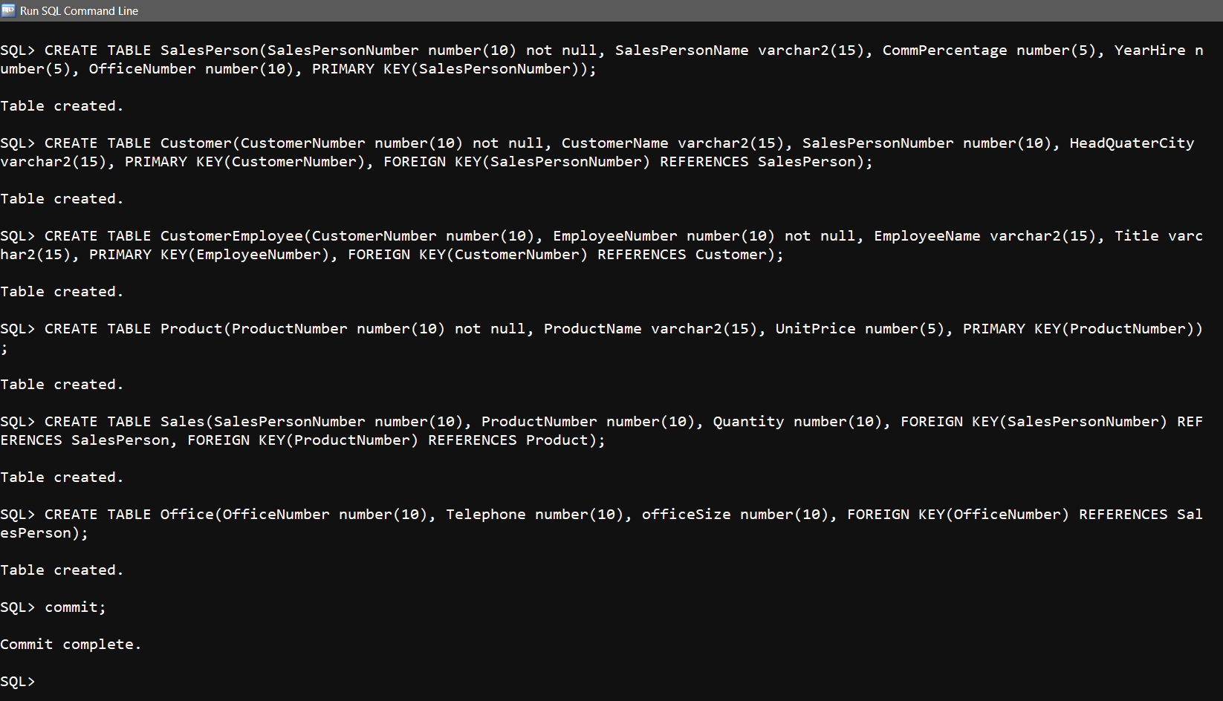

**Tables Description :**

> DESC SalesPerson;

> DESC Customer;

> DESC CustomerEmployee;

> DESC Product;

> DESC Sales;

> DESC Office;

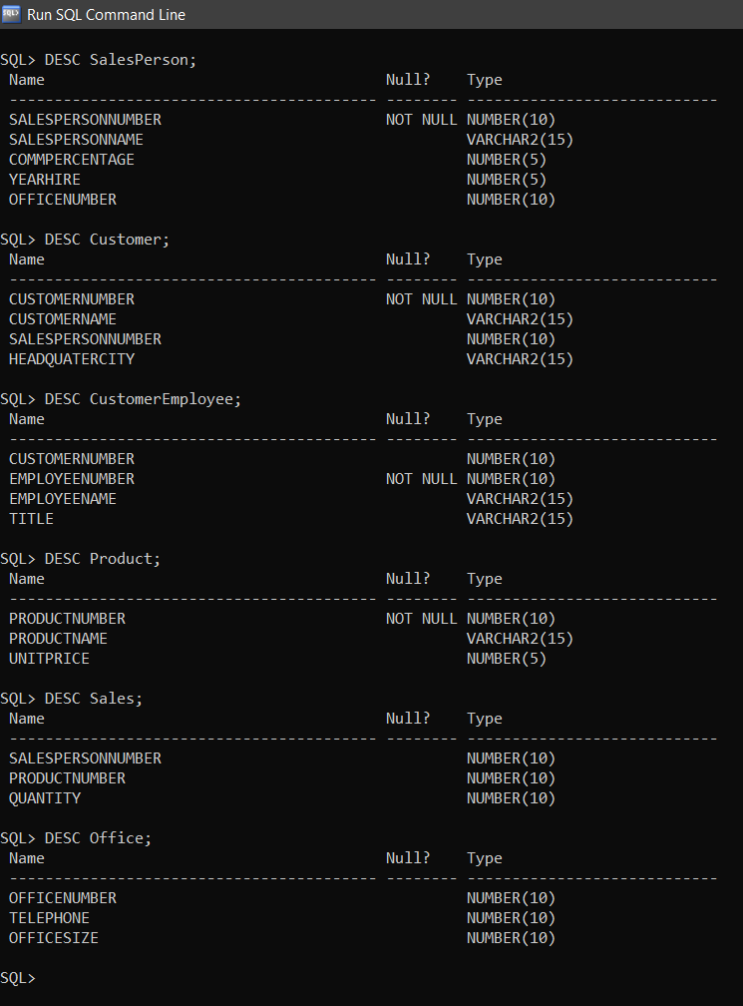

**Inserting Values :  
 SalesPerson Table**

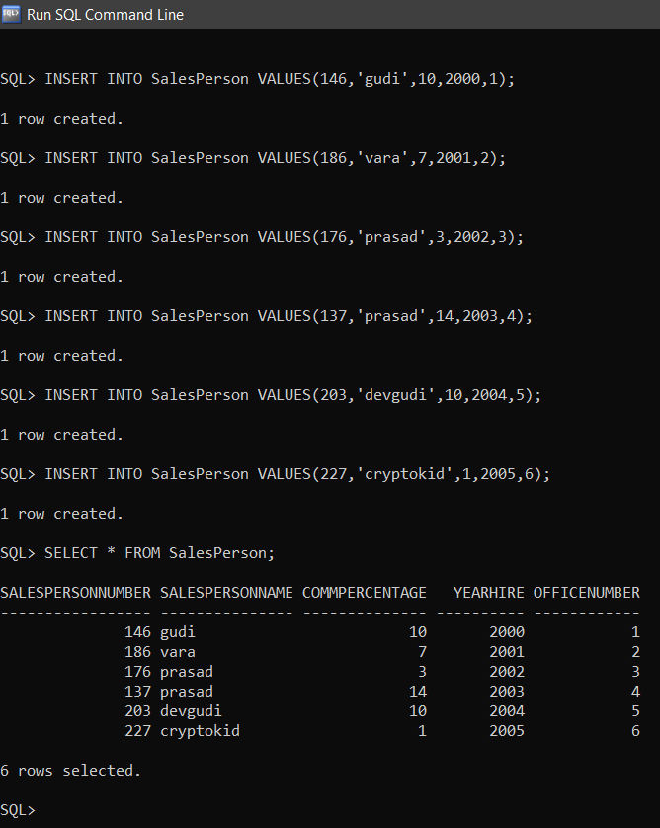

**Customer Table**

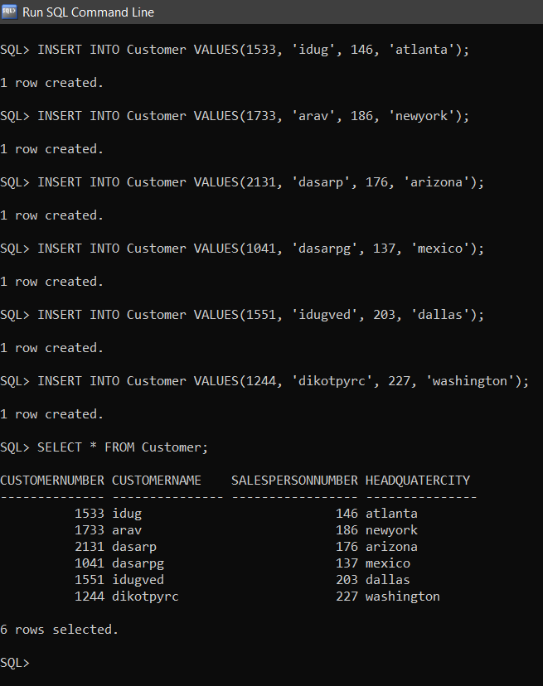

**CustomerEmployee**

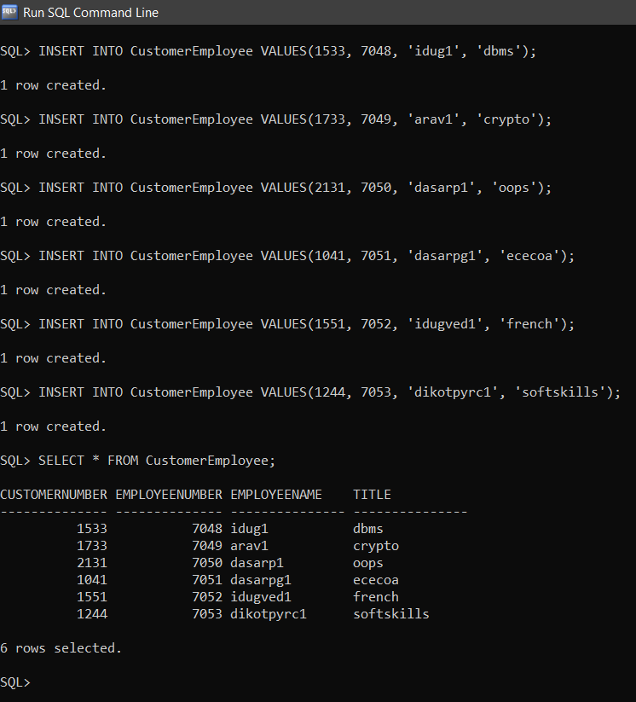

**Product Table**

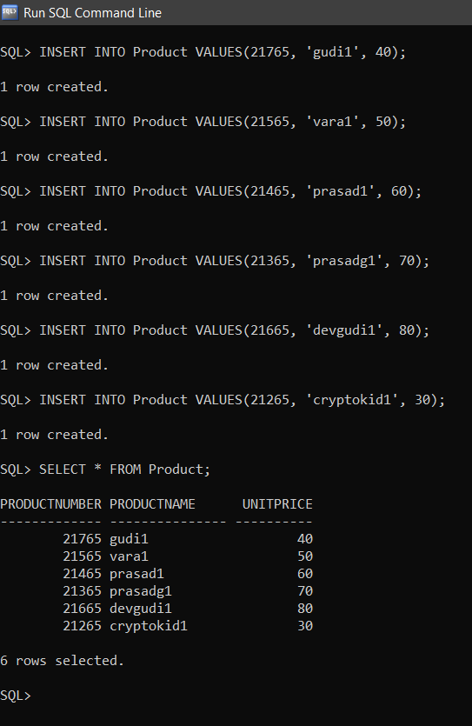

**Sales Table**

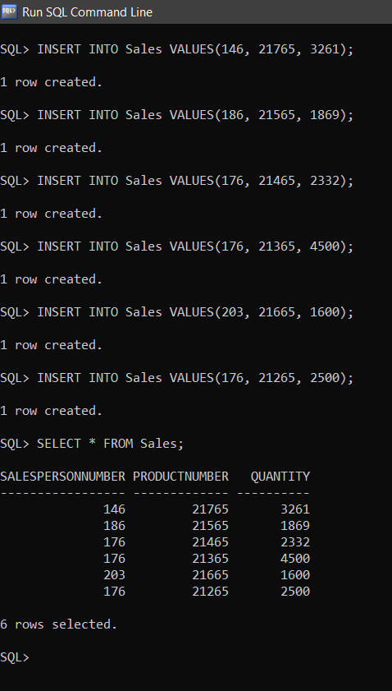

**Office Table**

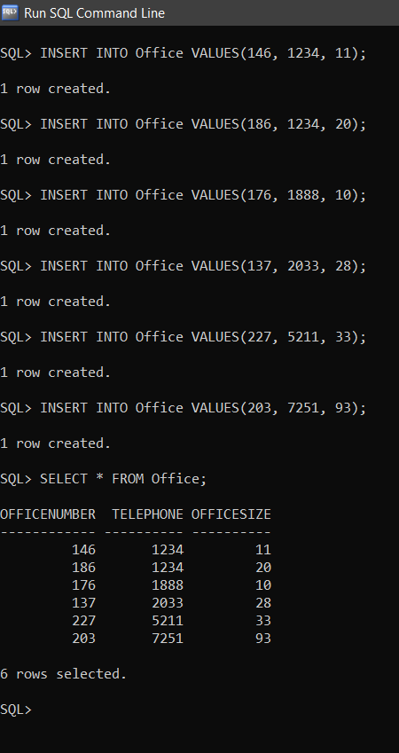

**Answer the following queries :**

**1. Find the commission percentage and year of hire of salesperson number 186.**

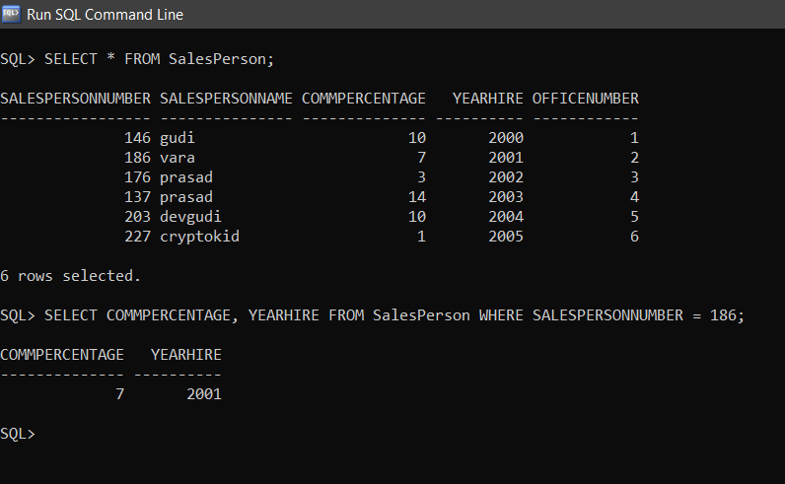

**2. List the salesperson numbers and salesperson names of those salespersons who have a commission percentage of 10.**

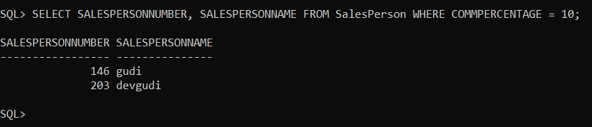

**3. List the salesperson number and salesperson name of all of the salespersons.**

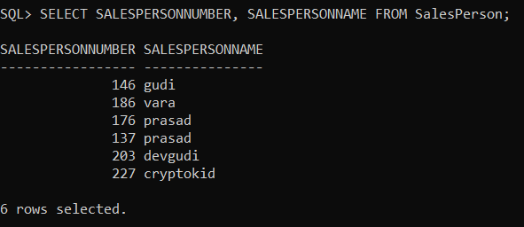

**4. List the salesperson numbers, salesperson names, and commission percentages of the salespersons whose commission percentage is less than 12.**

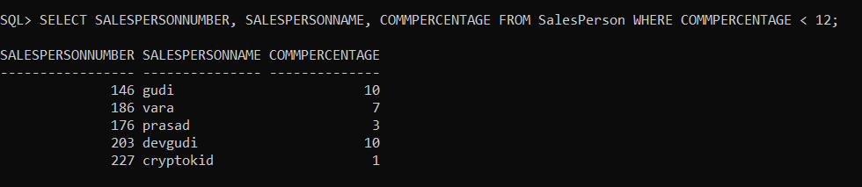

**5. List the customer numbers and headquarters cities of the customers that have a customer number of at least 1700.**

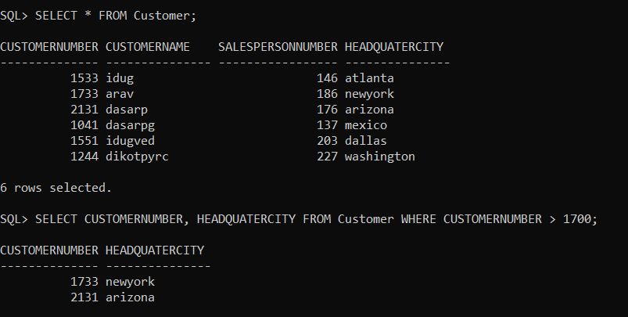

**6. List the customer numbers, customer names, and headquarters cities of the customers that are headquartered in New York and that have a customer number higher than 1500.**

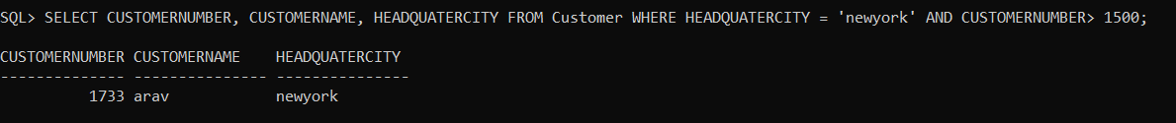

**7. List the customer numbers, customer names, and headquarters cities of the customers that are headquartered in New York or that have a customer number higher than 1500.**

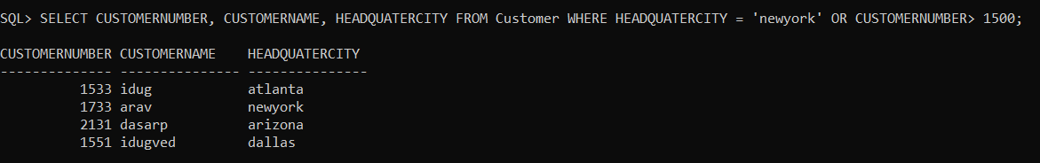

**8. List the customer numbers, customer names, and headquarters cities of the customers that are headquartered in New York or that satisfy the two conditions of having a customer number higher than 1500 and being headquartered in Atlanta.**

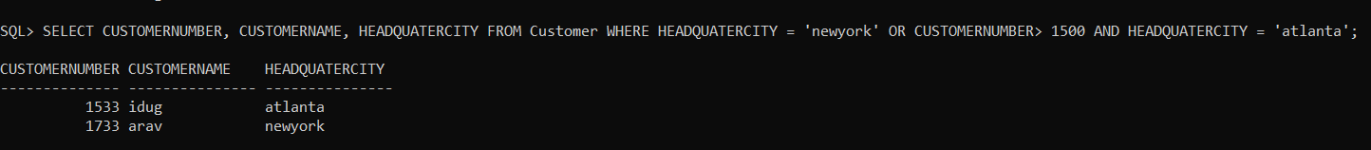

**9. Which cities serve as headquarters cities for General Hardware customers ?**

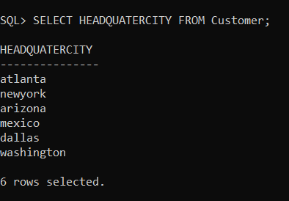

**10. Find the customer numbers, customer names, and headquarters cities of those customers with customer numbers greater than 1000. List the results in alphabetic order by headquarters cities.**



